East Boldon Neighbourhood Plan
Consultation on Draft Vision and Objectives

Drop in session, 10:00 am – 1:00 pm Saturday 23rd June 2018

East Boldon United Reformed Church Hall
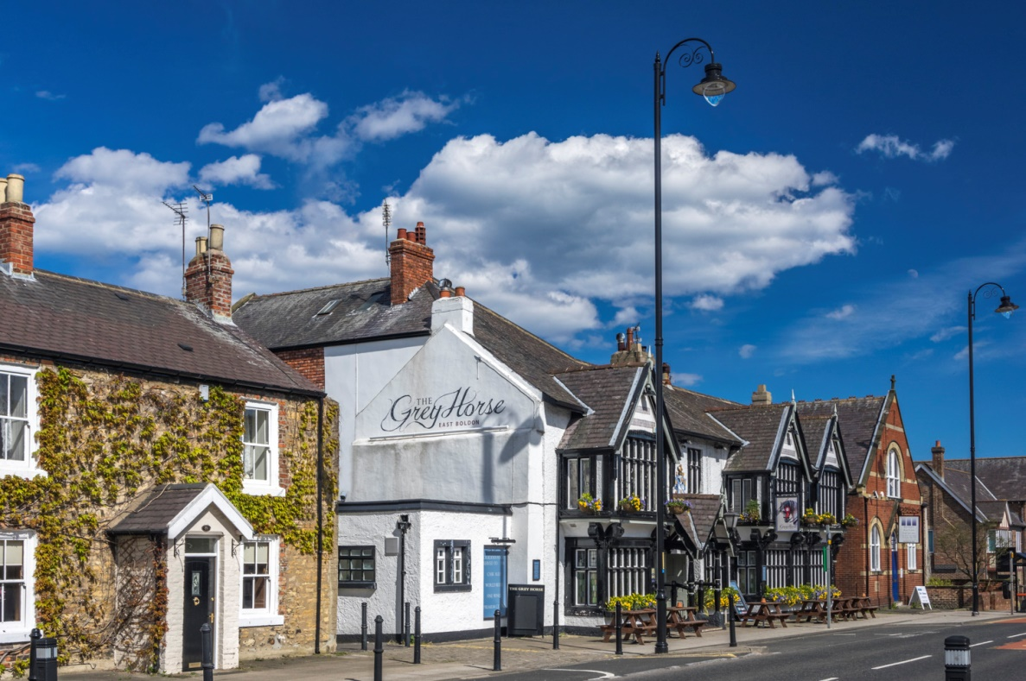
You may remember receiving a leaflet from us in May last year. In January 2018 the East Boldon Neighbourhood Forum was formally designated by South Tyneside Council.
We are starting to prepare a Neighbourhood Plan which will set out a clear vision for the area and help ensure development proposed in the Council’s Local Plan takes on board the views and needs of the East Boldon community.
We have produced a set of draft objectives setting out the issues we think should be addressed in the Neighbourhood Plan using your responses from our consultation event in July last year.
We need your support and are keen to hear your thoughts about the East Boldon Neighbourhood Plan and the issues you think it should address.
Please come along to the drop in session and let us know your views.
If you can’t make it to the event then please contact us via our website at www.EastBoldonForum.org.uk or join us at one of our monthly meetings held in the scout hut on the fourth Monday of the month.
Our draft objectives are:
- Ensure new development makes a positive contribution to social, environmental or economic needs and that any negative impacts are adequately mitigated.
- Ensure new development makes a positive contribution to a safe and well-designed built environment and that it respects the historic environment of the Neighbourhood Plan area.
- Plan positively for the creation, protection and enhancement of networks of biodiversity and green infrastructure in the Neighbourhood Plan area including ensuring that there are linkages to wider green infrastructure networks.
- Support the sustainable creation and protection of employment opportunities in the Neighbourhood Plan area and the vitality and viability of its Village and Local Centres.
- Create and maintain a balanced and sustainable community by providing a positive policy framework that recognises the different types of homes that all current and future residents of the Neighbourhood Plan area need.
- Contribute to community wellbeing by ensuring that the Neighbourhood Plan area’s community, especially its older and younger people, have access to the services and facilities they need.
- Reduce the causes and risk of flooding in the Neighbourhood Plan area.
- Manage the transport network of the Neighbourhood Plan area to be safer, more efficient and more environmentally friendly for all users, whilst ensuring adequate parking is available to meet the needs of residents, visitors and businesses.
Do you agree with them ?
What do you think should be included in the vision for the East Boldon Neighbourhood Plan?
Are there any other objectives that you think should be included?
The East Boldon Neighbourhood Forum area is shown in the map below:
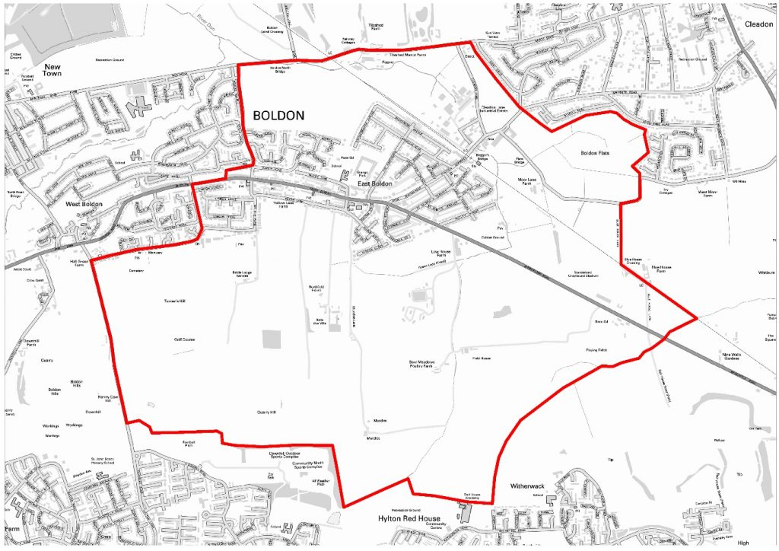

Come along on Saturday, 23 June 2018, share your views and join us!

